PRD for Firefox Affiliates Facebook Application
by Chelsea Novak, User Engagement
(Building on an idea proposed by Nobox)

Purpose
Build an application that ties a Affiliates referral application for Facebook with the existing Firefox Affiliates program. The application with have Facebook-specific affiliate buttons and functionality that allows affiliates to invite other friends to use Firefox.

Expanding the Affiliates program to Facebook, gives fans an opportunity to be an affiliate and spread the word about Firefox even if they don't own a website or blog. Also, by using the Facebook platform, we are adding millions of potential clicks to download by getting the word of mouth message in front of new eyeballs, as application activity will be shown in Timeline posts Timeline Activity, Dynamic Ads, the News Feed and Facebook Ticker.

As with the existing Affiliates program, high-performing and influential users can be rewarded with Mozilla gear. The opt-in, dynamic user-generated ads can also showcase contributors is various regions, further highlighting community-driven marketing efforts.

Stakeholder identification
Product owner: Chelsea Novak, User Engagement
Webprod: Will need to build and deploy the application and connect it to the existing Affiliates database
UX: for user flow within the application and how it connects to mozilla.org/firefox
L10n: This application will be required in the following locales: EN-US, ES,, FR, IT, JA, DE, PT-BR – We will have to find a way to get strings into the Facebook application.
User Engagement: Application will be built upon the existing Firefox Facebook page and Fan base
Creative: For creative assets required see below
-Copy – sign up process, ad options, invitation options, leaderboards, faq, about (application and Firefox), promotional ads
-Design – In app look and feel, app icons (large and small)
IT: Unsure
QA: We need to test the application as well as its effect on the existing Affiliates site
Legal: We will need help from privacy to ensure that this application is in line with our Privacy Policy as we're using the Facebook API.
Security: Security review will be required as we will have affiliate data passing between the Facebook API and the Firefox Affiliates application.

Market assessment and target geographies
The target geographies for the Firefox Affiliates Facebook application are EN-US, ES, DE, IT, FR, JA, KO and PT-BR. These are either geographies that are emerging Internet markets where we are planning to drive adoption of Firefox for Android or markets where we need to increase our market share for Firefox Desktop.

We currently have 9.4 million Facebook Firefox fans with an engagement rate of around 50%. Our current tracking data tells us that about half of our clicks on posts are made from a mobile device. Coupling that with the recent addition of ads on Facebook for mobile (showing up as a featured story) ensuring an easy path to the Firefox for Android download page for people who click on posts connected with the Firefox Affiliates Facebook application or who receive direct invitations from other friends is an important feature for the app.

Requirements
*Application will register users as a Firefox Affiliate in the Affiliates database
*Affiliates application will have to be able to differentiate if an affiliate is a Facebook affiliate and a regular Affiliate – This is so that their clicks can be counted as an aggregate
*Application will have to be available in multiple locales
*Application will have to give users maximal privacy options (actions taken by the app should be opt-in)

Workflow plans

Desktop – User Actions
These screen caps were developed by NoBox, who pitched this as an application separate to Affiliates in Q1, before Facebook timeline was rolled out to brands. These mockups are for inspiration only :)
- Install Firefox Affiliates Facebook Application
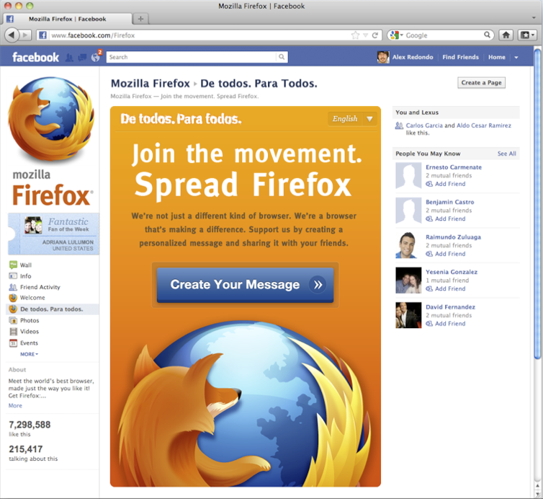

- Select country and language

- See welcome message (“It's as easy as 1-2-3”)
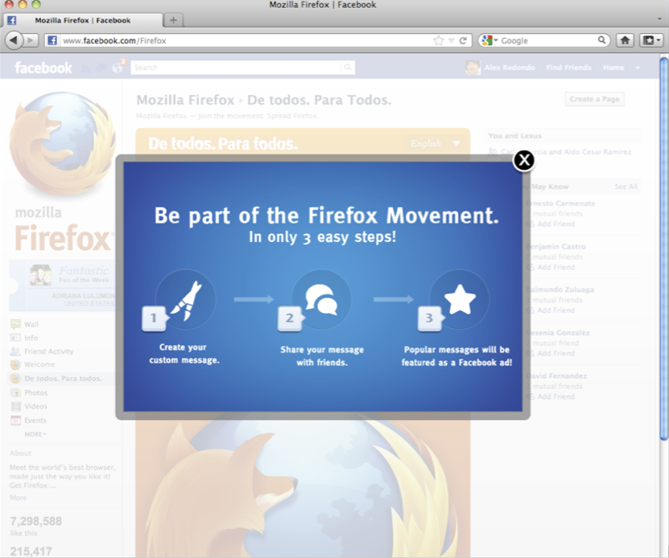

- a) Create and post “I love Firefox because...” message to their timeline

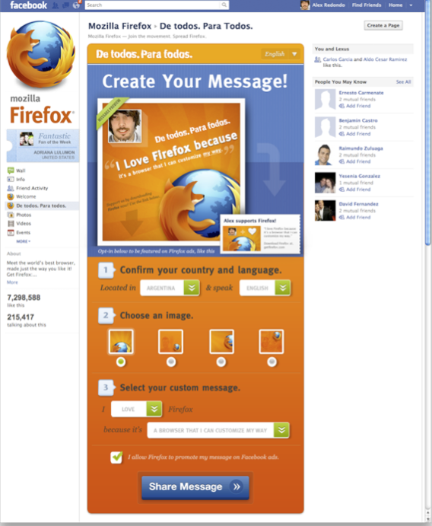
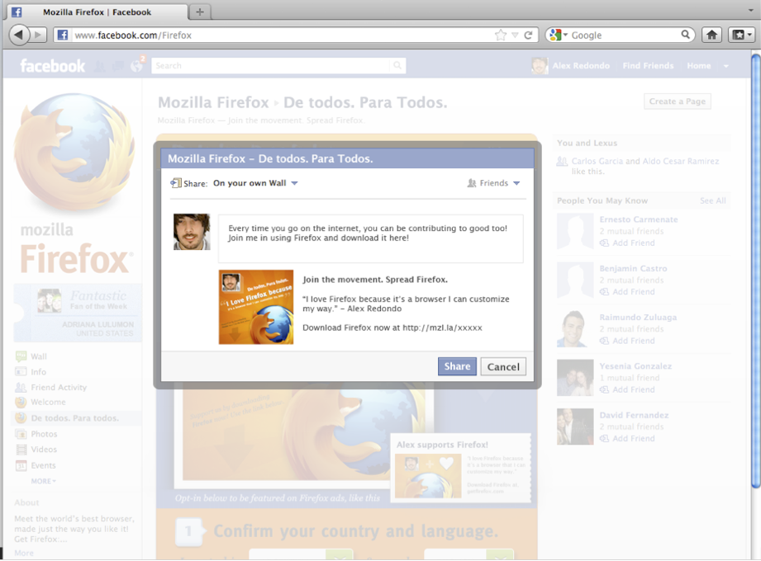

b) Directly invite Facebook Friends to download Firefox
This interaction needs to be mocked up, but in essence the user would select “Invite your friends directly to use Firefox” and be take to a page where they can select from 6 pre-population invitations and send it to friends on their list. That friend will then get a “Name has invited you to use Firefox – which when they click they'll be taken to the desktop or android download page (or if that's against the Facebook app rules, taken to a landing page in the app that displays the message from their friend and a download button).

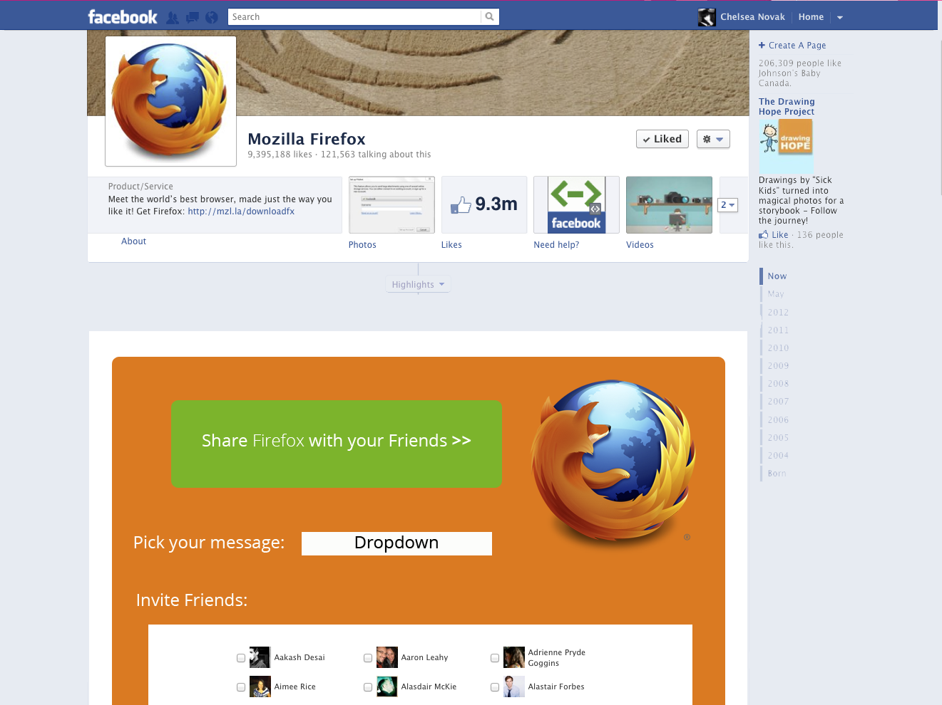

- Select whether or not they want to be a featured Mozillian in a paid Facebook add for Firefox
a) If yes, when they get 30 clicks from their post or invite, their ad is activated
b) If no, leave them be and let them share

This interaction will need to be connected with our Facebook ad account and see how much the new mobile promoted stories will add to the costing.
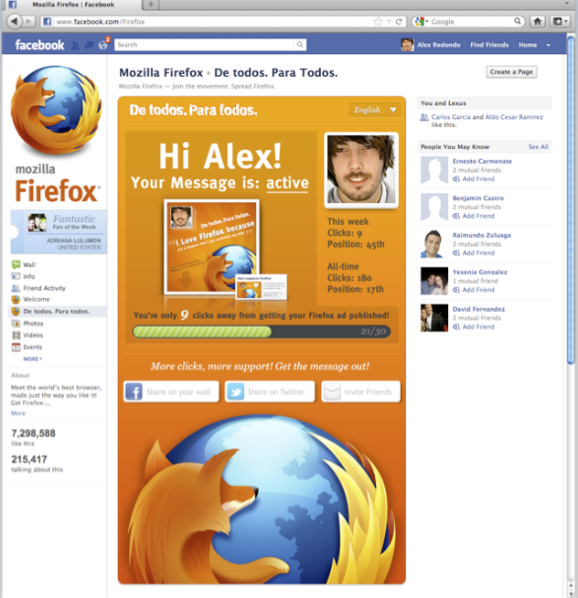
- Once complete, send them to the Leaderboards page where they can see where they stand in comparison to other users in their area, language and globally. The leaderboard page should also have links to invite more people, share their message again, link to Firefox Affiliates, invitation to sign up for the Firefox & You newsletter and a link to download firefox
Mobile – User Actions
Similar to the desktop process however, can a Facebook application detect the mobile OS a user is on? If so, and Facebook user who either clicks on a download link in an ad status update or invitation, the application should auto-route them to download Firefox for Android.

Pages required in the Facebook application:
- Welcome
- About (Information on Firefox and how this application works for users)
- Edit profile (users can add information and see how many clicks they have, but otherwise details will be populated by their Facebook data)
- Leaderboard (names of leaders should appear as first name and last initial) – can we toggle the leaderboard by county/language
(The leaderboard will become the home page after a user has been through the invitation process once) – page has a download Firefox link, an option to sign up for the Firefox Newsletter, and an option invite more Friends to download Firefox (sends them back through the invitation process)
- Invitation landing page (assuming Facebook won't let us do direct links to download)

What's required on Affiliates.mozilla.org:
- Link to the Facebook application in the menu
- Integration with the Django application so that existing Affiliates get credit for their clicks via the Facebook application (Not sure how we're going to solve the authorization issue or making sure that the accounts match)
- Facebook clicks counted in the Affiliates admin – breakout clicks via shares, ads and invitations

Timelines and milestones
PRD – June 7
Wireframes – June 18
Design (application and buttons) – June 22
Coding – June 22 – July 6
Review July 9
Launch July 15, 2012

Evaluation plan and performance metrics
If possible we need to find out how many clicks from the application are converted into downloads. At minimum we will need a WT tag to see how many clicks we are sending to mozilla.org/firefox and mozilla.org/mobile.

Metrics will be tracked weekly on Mondays and included in the weekly User Engagement status report

Targets
1 Million installs of the application in 2012
750,000 Clicks to Download Firefox Desktop in 2012
350,000 Clicks to Download Firefox for Android 2012

